LAB 2

**Q1:-The following SELECT statement executes successfully:**

**SELECT last_name, job_id, salary AS Sal FROM employees;**

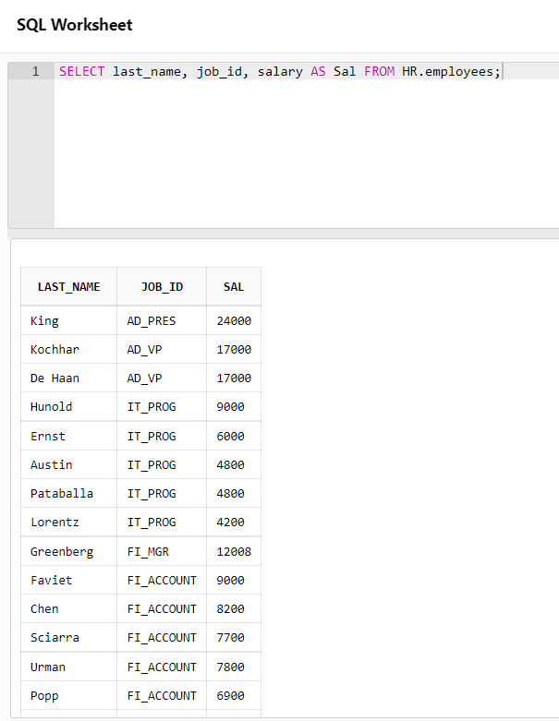

**Q2:-Show the structure of the DEPARTMENTS table. Select all data from the DEPARTMENTS table**

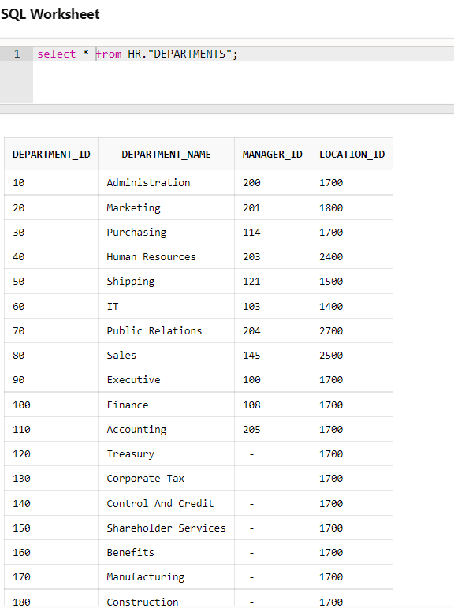

**Q3:-Show the structure of the EMPLOYEES table. Create a query to display the last name, job**

**code, hire date, and employee number for each employee, with employee number appearing first.**

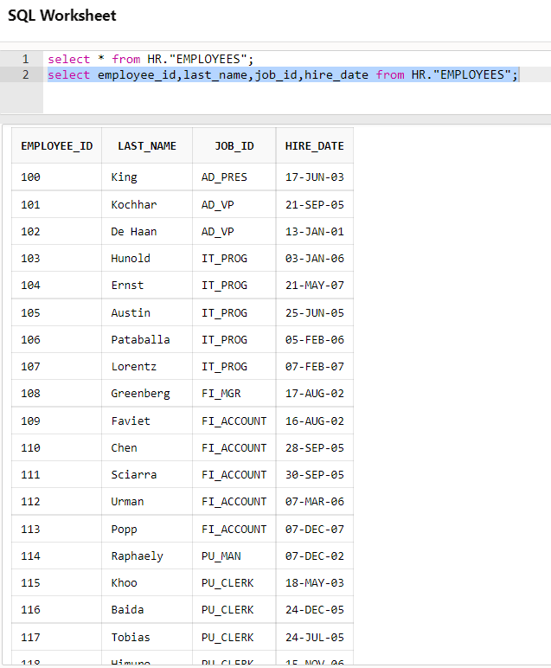

**Q4:-Create a query to display unique job codes from the EMPLOYEES table. Display the last name**

**concatenated with the job ID, separated by a comma and space, and name the column Employee**

**and Title.**

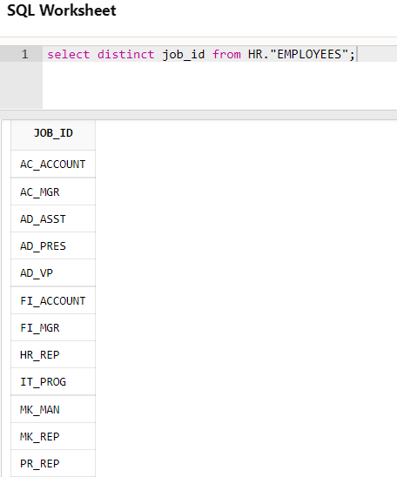

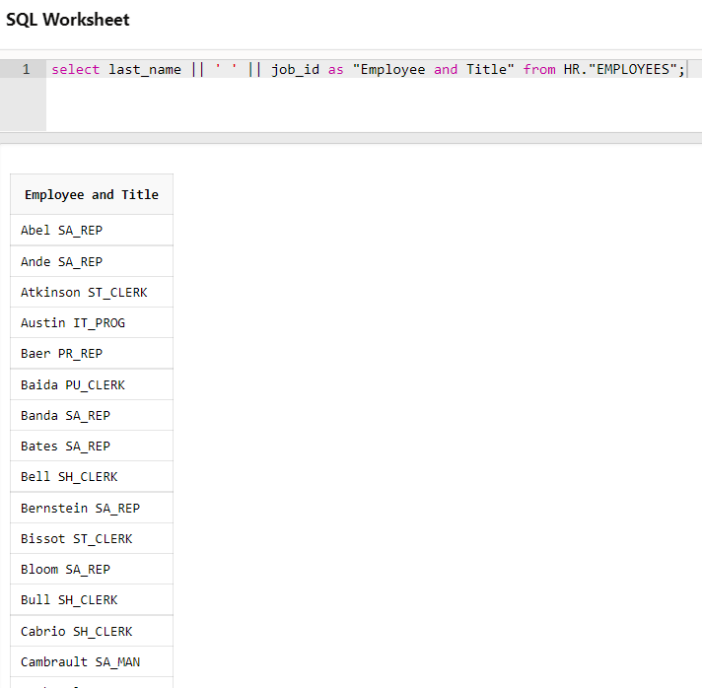

**Q5:-Create a query to display all the data from the EMPLOYEES table. Separate each column by a**

**comma. Name the column THE_OUTPUT.**

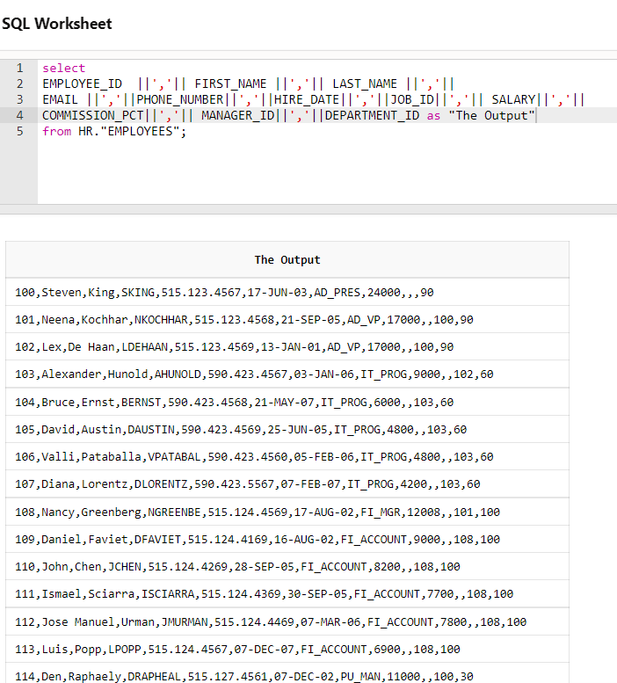

**Q6:-Create a query to display unique job codes from the EMPLOYEES table.**

